**Human-Computer Interaction**

**Human–computer interaction** (**HCI**) is research in the design and the use of [computer technology](https://en.wikipedia.org/wiki/Computing), which focuses on the [interfaces](https://en.wikipedia.org/wiki/Interface_(computing)) between people ([users](https://en.wikipedia.org/wiki/User_(computing))) and [computers](https://en.wikipedia.org/wiki/Computer). HCI researchers observe the ways humans interact with computers and design technologies that allow humans to interact with computers in novel ways.

As a field of research, human-computer interaction is situated at the intersection of [computer science](https://en.wikipedia.org/wiki/Computer_science), [behavioral sciences](https://en.wikipedia.org/wiki/Behavioural_sciences), [design](https://en.wikipedia.org/wiki/Design), [media studies](https://en.wikipedia.org/wiki/Media_studies), and [several other fields of study](https://en.wikipedia.org/wiki/Outline_of_human-computer_interaction#Related_fields). The term was popularized by [Stuart K. Card](https://en.wikipedia.org/wiki/Stuart_K._Card), [Allen Newell](https://en.wikipedia.org/wiki/Allen_Newell), and [Thomas P. Moran](https://en.wikipedia.org/wiki/Thomas_P._Moran) in their 1983 book, *The Psychology of Human-Computer Interaction,* although the authors first used the term in 1980,[[1]](https://en.wikipedia.org/wiki/Human%E2%80%93computer_interaction#cite_note-The_keystroke-level_model_for_user_performance_time_with_interactive_systems-1) and the first known use was in 1975.[[2]](https://en.wikipedia.org/wiki/Human%E2%80%93computer_interaction#cite_note-Evaluating_the_impact_of_office_automation_on_top_management_communication-2) The term is intended to convey that, unlike other tools with specific and limited uses, computers have many uses which often involve an open-ended dialogue between the user and the computer. The notion of dialogue likens human-computer interaction to human-to-human interaction: an analogy that is crucial to theoretical considerations in the field

**Introduction-**

Humans interact with computers in many ways, and the interface between the two is crucial to facilitating this [interaction](https://en.wikipedia.org/wiki/Interaction). HCI is also sometimes termed *human–machine interaction* (HMI), *man-machine interaction* (MMI) or *computer-human interaction* (CHI). Desktop applications, internet browsers, handheld computers, and computer kiosks make use of the prevalent [graphical user interfaces](https://en.wikipedia.org/wiki/Graphical_user_interface) (GUI) of today.[[5]](https://en.wikipedia.org/wiki/Human%E2%80%93computer_interaction#cite_note-ACM_SIGCHI-5) [Voice user interfaces](https://en.wikipedia.org/wiki/Voice_user_interface) (VUI) are used for [speech recognition](https://en.wikipedia.org/wiki/Speech_recognition) and synthesizing systems, and the emerging [multi-modal](https://en.wikipedia.org/wiki/Multimodal_interaction) and Graphical user interfaces (GUI) allow humans to engage with [embodied character agents](https://en.wikipedia.org/wiki/Embodied_agent) in a way that cannot be achieved with other interface paradigms. The growth in human–computer interaction field has led to an increase in the quality of interaction, and resulted in many new areas of research beyond. Instead of designing regular interfaces, the different research branches focus on the concepts of [multimodality](https://en.wikipedia.org/wiki/Multimodality)[[6]](https://en.wikipedia.org/wiki/Human%E2%80%93computer_interaction#cite_note-6) over unimodality, intelligent adaptive interfaces over command/action based ones, and active interfaces over passive interfaces.[[*citation needed*](https://en.wikipedia.org/wiki/Wikipedia:Citation_needed)]

The [Association for Computing Machinery](https://en.wikipedia.org/wiki/Association_for_Computing_Machinery) (ACM) defines human-computer interaction as "a discipline that is concerned with the design, evaluation, and implementation of interactive computing systems for human use and with the study of major phenomena surrounding them".[[5]](https://en.wikipedia.org/wiki/Human%E2%80%93computer_interaction#cite_note-ACM_SIGCHI-5) An important facet of HCI is user satisfaction (or End-User Computing Satisfaction). It goes on to say:

"Because human-computer interaction studies a human and a machine in communication, it draws from supporting knowledge on both the machine and the human side. On the machine side, techniques in [computer graphics](https://en.wikipedia.org/wiki/Computer_graphics), [operating systems](https://en.wikipedia.org/wiki/Operating_system), [programming languages](https://en.wikipedia.org/wiki/Programming_language), and development environments are relevant. On the human side, [communication theory](https://en.wikipedia.org/wiki/Communication_theory), [graphic](https://en.wikipedia.org/wiki/Graphic_design) and [industrial design](https://en.wikipedia.org/wiki/Industrial_design) disciplines, [linguistics](https://en.wikipedia.org/wiki/Linguistics), [social sciences](https://en.wikipedia.org/wiki/Social_science), [cognitive psychology](https://en.wikipedia.org/wiki/Cognitive_psychology), [social psychology](https://en.wikipedia.org/wiki/Social_psychology), and [human factors](https://en.wikipedia.org/wiki/Human_factors) such as [computer user satisfaction](https://en.wikipedia.org/wiki/Computer_user_satisfaction) are relevant. And, of course, engineering and design methods are relevant."[[5]](https://en.wikipedia.org/wiki/Human%E2%80%93computer_interaction#cite_note-ACM_SIGCHI-5)

Due to the multidisciplinary nature of HCI, people with different backgrounds contribute to its success.

Poorly designed [human-machine interfaces](https://en.wikipedia.org/wiki/Human-machine_interface) can lead to many unexpected problems. A classic example is the [Three Mile Island accident](https://en.wikipedia.org/wiki/Three_Mile_Island_accident), a nuclear meltdown accident, where investigations concluded that the design of the human-machine interface was at least partly responsible for the disaster.[[7]](https://en.wikipedia.org/wiki/Human%E2%80%93computer_interaction#cite_note-What_is_Cognitive_Ergonomics?-7)[[8]](https://en.wikipedia.org/wiki/Human%E2%80%93computer_interaction#cite_note-NRC:_Backgrounder_on_the_Three_Mile_Island_Accident-8)[[9]](https://en.wikipedia.org/wiki/Human%E2%80%93computer_interaction#cite_note-three_mile_island-9) Similarly, accidents in aviation have resulted from manufacturers' decisions to use non-standard [flight instruments](https://en.wikipedia.org/wiki/Flight_instruments#Layout) or throttle quadrant layouts: even though the new designs were proposed to be superior in basic human-machine interaction, pilots had already ingrained the "standard" layout. Thus, the conceptually good idea had unintended results.

**The Meteoric Rise of HCI**

HCI surfaced in the 1980s with the advent of personal computing, just as machines such as the Apple Macintosh, IBM PC 5150 and Commodore 64 started turning up in homes and offices in society-changing numbers. For the first time, sophisticated electronic systems were available to general consumers for uses such as word processors, games units and accounting aids. Consequently, as computers were no longer room-sized, expensive tools exclusively built for experts in specialized environments, the need to create human-computer interaction that was also easy and efficient for less experienced users became increasingly vital. From its origins, HCI would expand to incorporate multiple disciplines, such as computer science, cognitive science and human-factors engineering. cognitive science and human-factors engineering.

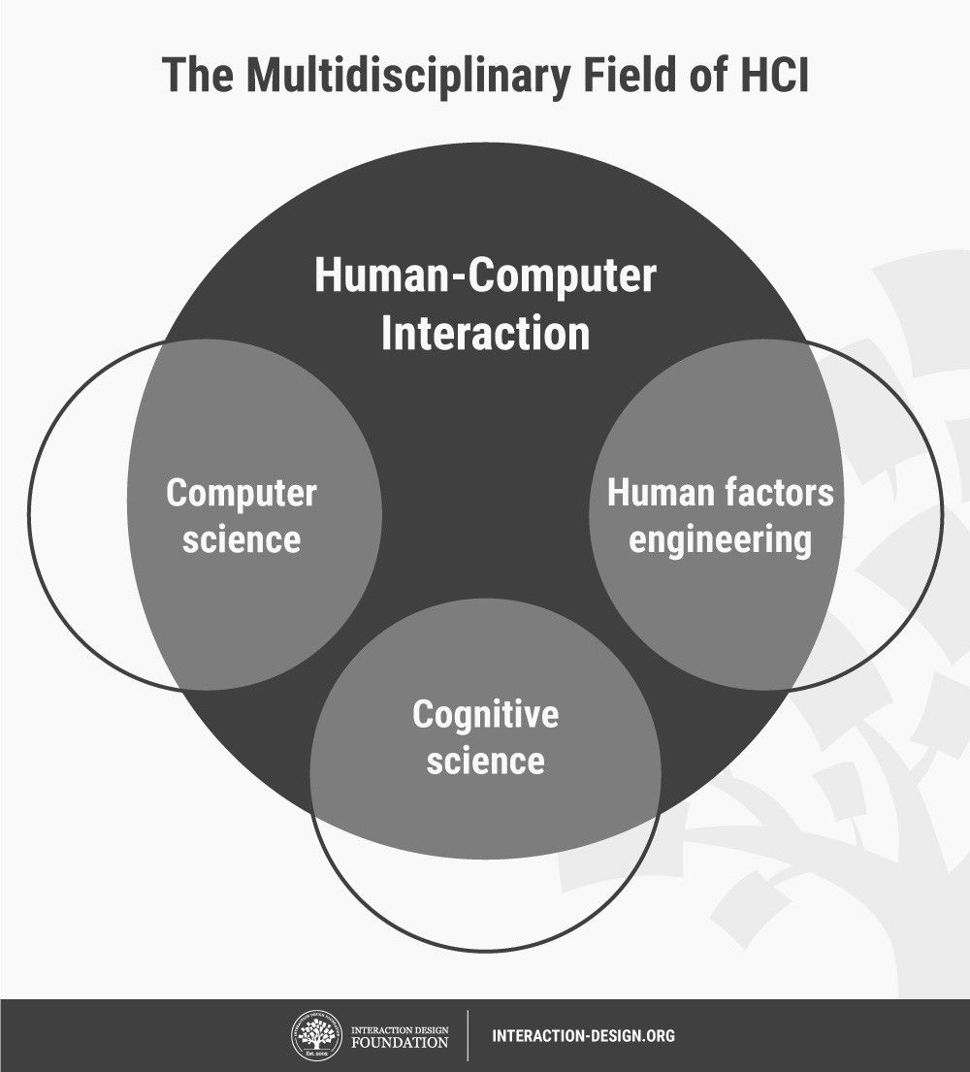

HCI soon became the subject of intense academic investigation. Those who studied and worked in HCI saw it as a crucial instrument to popularize the idea that the interaction between a computer and the user should resemble a human-to-human, open-ended dialogue. Initially, HCI researchers focused on improving the usability of desktop computers (i.e., practitioners concentrated on how easy computers are to learn and use). However, with the rise of technologies such as the Internet and the smartphone, computer use would increasingly move away from the desktop to embrace the mobile world.

**References**

The Interaction Design Foundation’s encyclopedia chapter on Human-Computer Interaction, by John M. Carroll, a founder of HCI, is an ideal source for gaining a solid understanding of HCI as a field of study: <https://www.interaction-design.org/literature/book/the-encyclopedia-of-human-computer-interaction-2nd-ed/human-computer-interaction-brief-intro>

Keep up to date with the latest developments in HCI at the international society for HCI, SIGCHI: <https://sigchi.org/>

Learn the tools of HCI with our course on HCI, taught by Professor Alan Dix, author of one of the most well-known textbooks on HCI. You can find it here: <https://www.interaction-design.org/courses/human-computer-interaction>